**Source 1 The Tribune, 1943**

**Source 2**

The sympathy which the right honourable Member for Kooyong [Menzies] expressed for my distinguished predecessor [Scullin] would never have been necessary if the Commonwealth Bank in 1931 had done for Labor what it did for our opponents on the outbreak of war in 1939, when central bank credit was used in the national interest by the Government in a perfectly proper manner. I do not condemn what was done in 1939, but I cannot be blamed for drawing attention to the treatment received by [Scullin] who, *in worse circumstances*, had the door bolted against him while the country was forced through the misery of a depression which might not have been so serious but for the action of those who had no responsibility, and who used their power for their own ends and to defeat the Government.

**Speech by John Curtin, 1941**

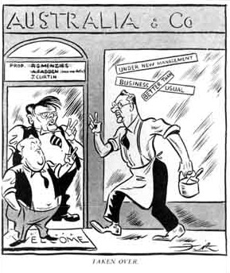**Source 3**

**John Frith, "Taken Over", 8 October 1941, in The Bulletin p.10.   
Courtesy of the University of Western Australia Library and the Frith family.**

**Source 4**

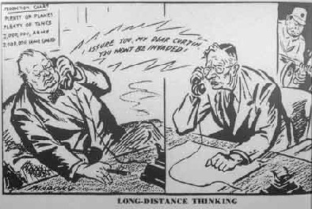

**William Mahony, 'Long distance thinking', Daily Telegraph, 1942.**

**Source 5**

...imposing responsibilities upon the Commonwealth Government on the one hand to develop a progressive and comprehensive post-war policy, and of imposing responsibilities on the State legislatures and governments on the other hand to cooperate fully in the administration of a national plan for reconstruction... The primary responsibility for post-war reconstruction rests on the Commonwealth and that Parliament should have the powers necessary for it to face up to that responsibility.

**A Department of Post-war Reconstruction was established at the end of 1942, with Chifley as Minister.**

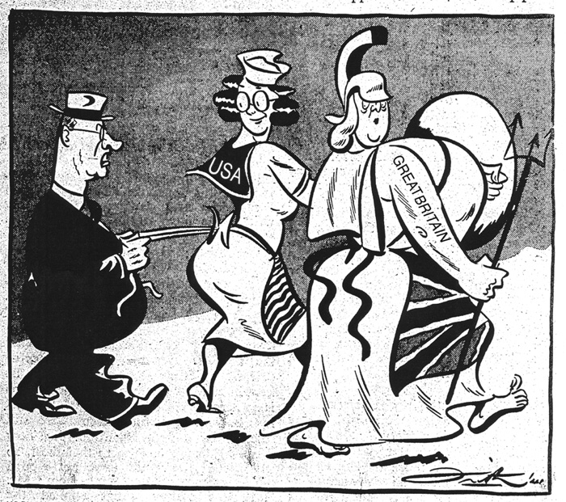

**Source 6**

**Curtin: 'No offence, mum, but I'm shifting to these here apron strings - at least  
for twenty-four hours' cartoon by John Frith.  
The Bulletin 31 December 1941. Courtesy Frith** Family.

**Source 7**

I resolved that America should not go to sleep upon its responsibility ... We had been fighting for two years before you started. The struggle for Australia I felt was vital to the global war against the enemy Powers as was the preservation of any other important strategic locations which were being fought for ... I put it to you quite flatly: If Australia had gone you would have had no place open for a base from which to fight the Japanese.

**Curtin’s comments as he was viewing a post war world, 1944.**

**Source 8**

“I have had the privilege of leading the Labor Party for nearly four years. They have not been easy times and it has not been an easy job. It is a man-killing job and would be impossible if it were not for the help of my colleagues and members of the movement. No Labor Minister or leader ever has an easy job. The urgency that rests behind the Labour movement, pushing it on to do things, to create new conditions, to reorganise the economy of the country, always means that the people who work within the Labour movement, people who lead, can never have an easy job. The job of the evangelist is never easy. Because of the turn of fortune’s wheel your Premier (Mr McGirr) and I have gained some prominence in the Labour movement. But the strength of the movement cannot come from us. We may make plans and pass legislation to help and direct the economy of the country. But the job of getting the things the people of the country want comes from the roots of the Labour movement – the people who support it. When I sat at a Labor meeting in the country with only ten or fifteen men there, I found a man sitting beside me who had been working in the Labour movement for fifty-four years. I have no doubt that many of you have been doing the same, not hoping for any advantage from the movement, not hoping for any personal gain, but because you believe in a movement that has been built up to bring better conditions to the people. Therefore, the success of the Labour Party at the next elections depends entirely, as it always has done, on the people who work.

I try to think of the Labour movement, not as putting an extra sixpence into somebody’s pocket, or making somebody Prime Minister or Premier, but as a movement bringing something better to the people, better standards of living, greater happiness to the mass of the people. We have a great objective – the light on the hill – which we aim to reach by working the betterment of mankind not only here but anywhere we may give a helping hand. If it were not for that, the Labour movement would not be worth fighting for.

If the movement can make someone more comfortable, give to some father or mother a greater feeling of security for their children, a feeling that if a depression comes there will be work, that the government is striving its hardest to do its best, then the Labour movement will be completely justified.

It does not matter about persons like me who have our limitations. I only hope that the generosity, kindliness and friendliness shown to me by thousands of my colleagues in the Labour movement will continue to be given to the movement and add zest to its work.”

**– JB. Chifley in speech to the NSW Labor Party Conference, 12 June 1949**